

T.E.A.M April Newsletter 2025



-

-

-

•

•



Bensalem Senior Center

l 850 Byberry Road

215-638-7720

Ap ril Message from the Direc tor

Hello Members and welcome to the start of nicer weather (hopefully)

This month we are starting to pick back up with events, adding some new activities and unfourtantley stopping some. Woodburning on Thursdays will no longer be an activity, thank you to Pat for doing it as long as he has and it will be missed!

Sams Club will be here April 2 for discounted membership cards, Weight Watchers will be here starting on Friday April 4, this is an at cost activity since they are renting the building but if you are interested they will be here to discuss price, April 17 Bucks County Transit will be here, April 22 Balance and Fall prevention will be bringing pizza for members who attend the presentation, so please see Suzann to sign up so they can order accordingly and April 24th is the Darts Luncheon, for any further details on the luncheon please see Gus.

As you noticed we have our wonderful Lisa at the front desk who has been volunteering everyday- if you are interested in volunteering to help Lisa out please see Suzann so we can possibly give Lisa a little bit of a break. We also have a Trustee position open so if you are willing to help in that department as well that would be greatly appreciated.

Taxes will be done this month and Line Dancing will resume, unsure of the exact date but it will be back! Shuffleboard season has also begun so if you have any question about the season please see Liz.

Haircuts will also be this month as well just waiting on dates so please check in periodically for that!

Again, if you have any interest in a new activity or would like to volunteer my door is o p e n . Please remember I am human I sometimes over schedule and overlook small details so please forgive me!

Thank you for another great month and I am sure I speak for most when I say I am looking forward to warmer days!

Love Suzann

Message from the President

Skies are Bluer days are warmer... Happy Easter and Happy Passover to one and all.

This year is flying by. Our activities are moving right along. Monday and Tuesday mornings, we have Tai Chi classes, thanks to our two wonderful instructors. We are so grateful for Pat Gavigan and Joseph Di Nardo for getting this class together. You are all welcome to join this class.

Shuffleboard is all aboard now that April is here. Teams were selected so as they say "let the games begin". Now that Shuffleboard is beginning we are ending our dart Season. The Dart players will soon enjoy their luncheon and awards on April 24th• Thank you, Gus Cales, for running all this!

Our Spring Fling Bingo is on May 4th• We have great cash prizes as well as wonderful raffle baskets, gift auction and gift cards. Thanks so much to those who donated to this event. We still could use more gift cards and new items so if you are willing to help with that please let me know.

On May 16 th we are having a memorial celebration of life to memorialize our Vice President Dolores Lynam as well as our past President Tom Amerman who recently passed away. Check out notices for further details.

Keeping looking out for our new trips! Florence and Dianna have been diligently working on this, both women do an awesome job and we thank them.

Once again as President I want to thank all of you for your cooperation with me. Last month our member of t he month was Drexel Harris. She is our Bingo Chairperson. Please continue to give me more suggestions for this M.O.M award.

Have a wonderful spring!

Love to all of you Judy

Upcoming Events in April

April 2- Sams Club Coming for Discount Sign Ups @10am April 17- Bucks County Transit @10am

April 22- Fyzical- Therapy and Balance @ 12pm- Pizza

Party- Please Sign up!!

April 24 - Dart Luncheon @ 12pm

April 25 - Jefferson Healthy Eating @ 10:30am

Lunch Every Monday- Friday @11am

**PLEASE** Preregister on Copilot

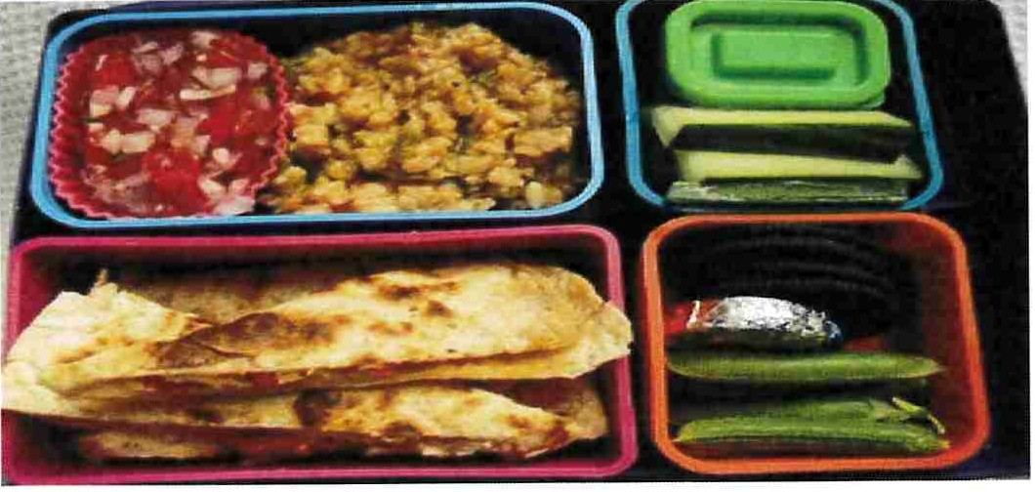

Plea se Be sure to Regi st er !!

**flFYZICAt**

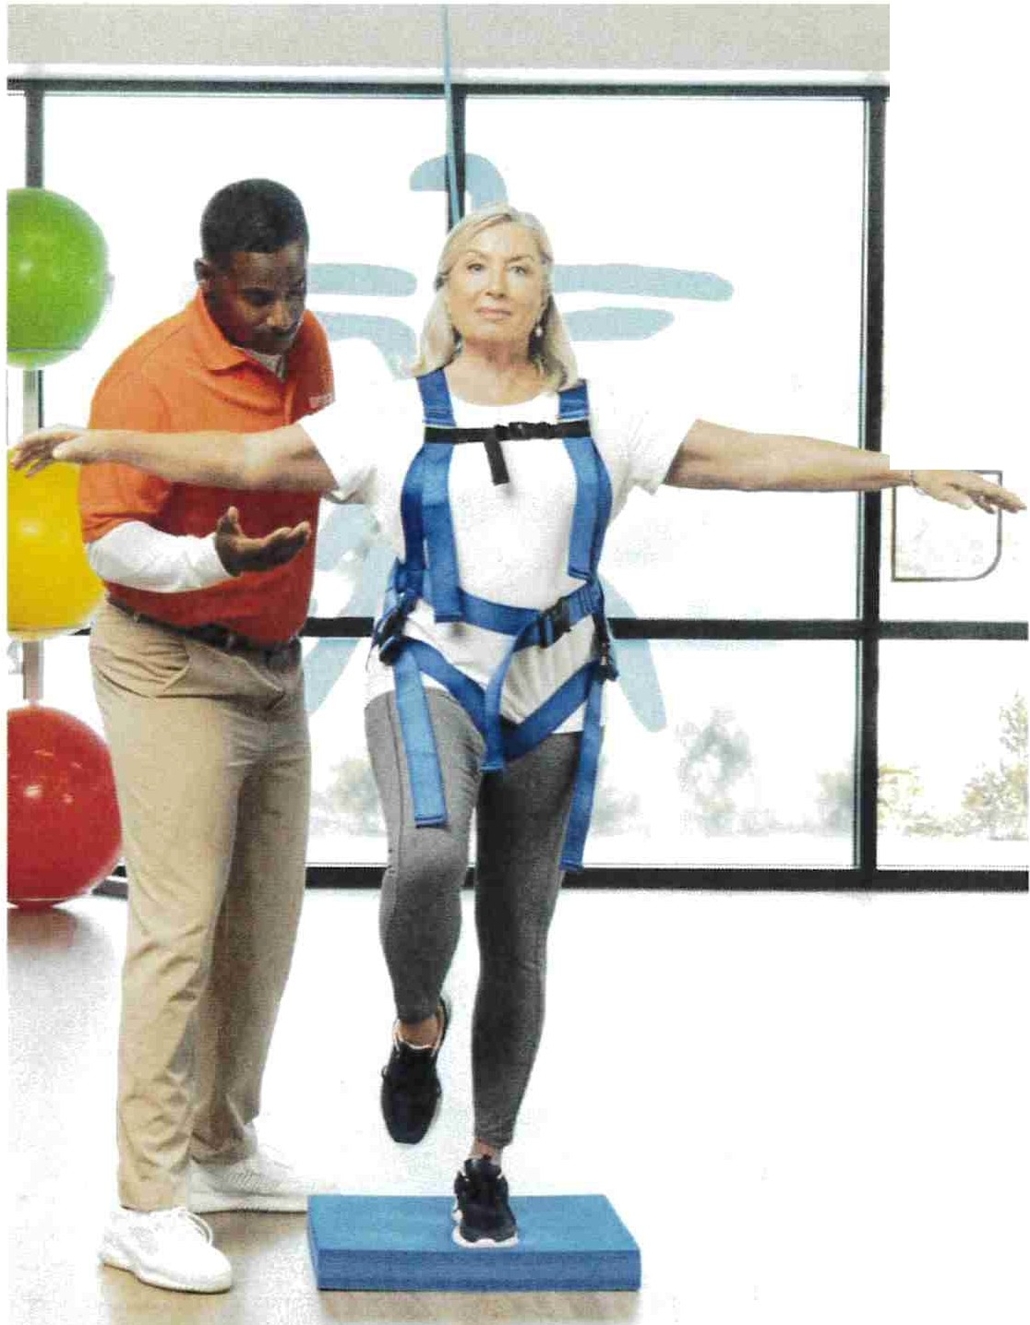

I I

□[I

Therapy & Balance Centers

#### FALLS ARE NOT

**A NORMAL PART OF AGING**

As we age, it's natural to worry about falling. However, it's important to understand that falls are not an inevitable part of aging. At FYZICAL Therapy & Balance Centers, we specialize in fall prevention and empower older adults to feel confident, maintain mobility, and stay steady on their feet. FYZICAL is offering free Fall Risk Screenings to identify those at risk of falling to prevent future injuries. We b elieve that balance is core to your wellness!

FYZICAL IS C AND LEARN FROM 12:00-

|  |  |  |  |
| --- | --- | --- | --- |
| **OMING** | | **FOR** | **A LU** |
| **ON THURSDAY,** | | | |
| **1:30p.** | **PIZZA** | | **PAR** |

**NCH 4/24 TY!!!!!**

l)Lec 5fN5 *CJP .* .

**SIGN UP HERE:**

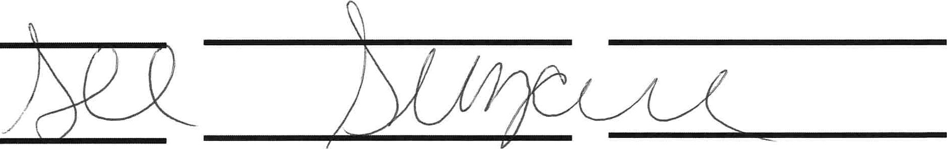

■ ■ ■ ■ ■ ■ ■ ■ ■ ■ ■ ■ ■ ■ ■ ■ ■ ■ ■ ■ ■ ■ ■ ■ ■ ■ ■ ■ ■ ■ ■

,

##### ■

■

■

■

■

■

■

**11** ■

•

##### ■

The ***Poetry* & *Prose*** group is organized around a love of language.

***0***

### We write, share stories, discuss short literary works, and relate these to other art forms and our own lives.

Everyone is welcome to join us for fun and intellectual stimulation.

We meet every Wednesday 10:00

to11:00 in the conference room.

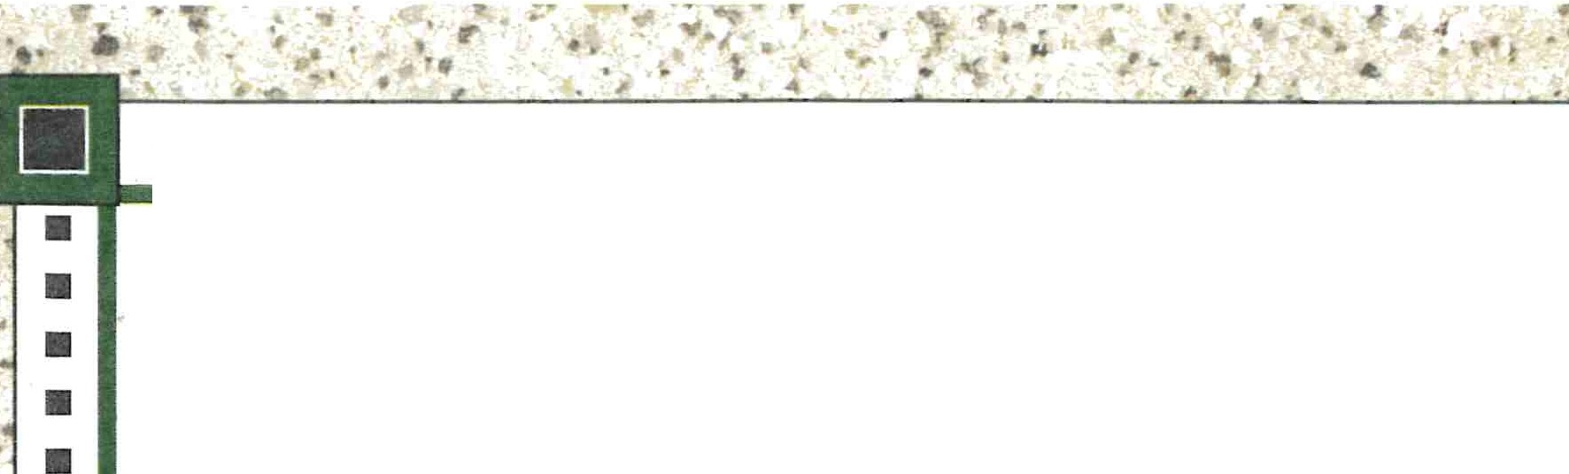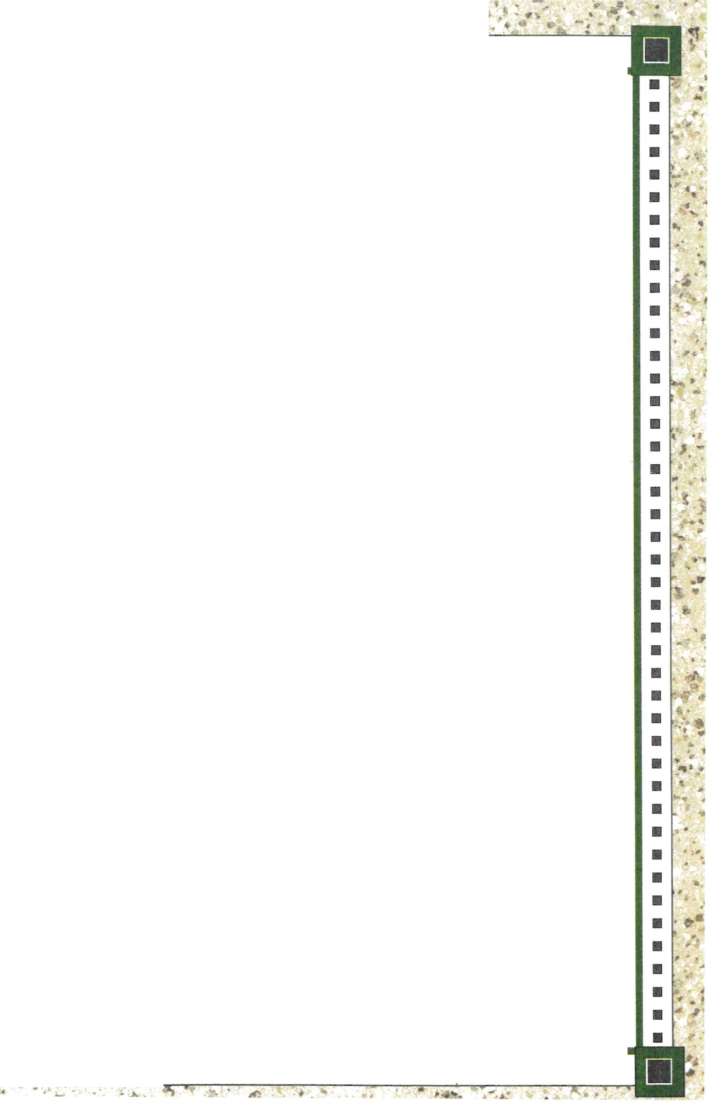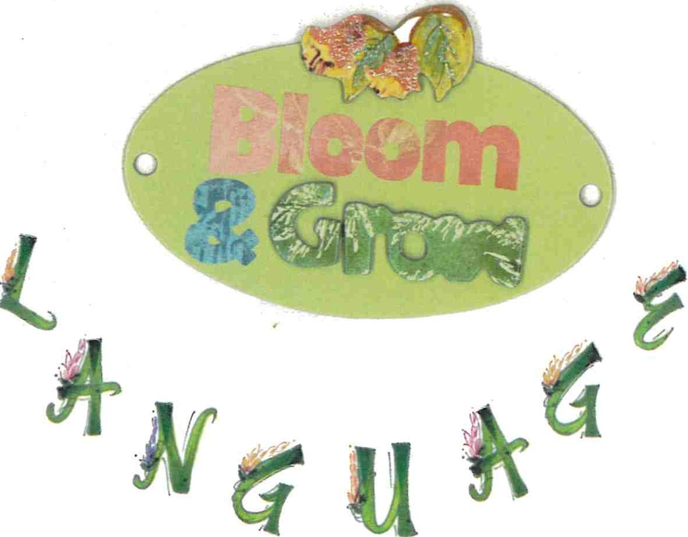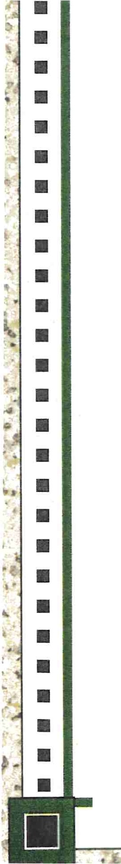

##### ■ ■ ■ ■ ■ ■ ■ ■·■ ■ ■ ■ ■ ■ ■ ■ ■ ■ ■ ■ ■ ■ ■ ■ ■ ■ ■ ■ ■ ■ ■

Healthy Eating Class

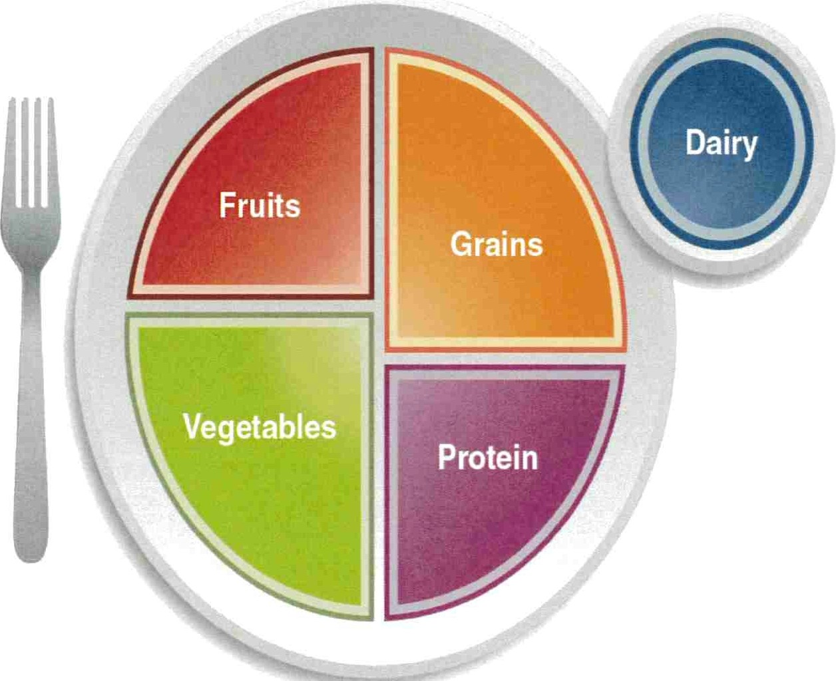

**Choo seMyPlate .gov**

## Next Session is April 25, 2025

@ 10:30am

## At Bensalem Senior Center In the conference rooml

... **'l'Jfe** . . . "



**Nu:tr**.·**i:**.•**t**.-**it>t.qtt.l:ifp'**

**Monday**

**Colleen Brawn MA RD LDN #948038**

**CHICKEN CAESAR SALAD**

**4**

**GARDEN SALAD W CHICKEN SEAFOOD SALAD PLATTER W CHEESE HONEY MUSTARD SLICED CHICKEN**

**\*Menu subject to change**

(3oz EP chicken, 1/2 whole HB egg, 1 (2oz EP chicken, 1 HB egg, 0.5oz (3oz EP surimi, 1 oz cheddar cheese) **WRAP** {3oz EP chicken, 1 T Honey cup romaine lettuce, 1 T croutons, 1T shredded cheese, 1 cup romaine, 1 pkt *½* cup marinated tomato and white mustard )

Caesar dressing) low sodium, low fat Italian dressing) bean *½* cup Greek orzo salad {orzo, tomato,

*½* cup pasta salad w peppers *½* cup tomato and cucumbers *½* cup marinated cucumber and onion cucumber, chickpeas, olives)

*½* cup marinated tomato salad *½* cup cold couscous w peppers salad ½ cup marin. carrot & cauliflower salad

1 oz WW bread, pc marg 1 slice WW bread, pc margarine 2oz WW roll, margarine 6" whole wheat tortilla

r------------- Sugar Cookie Fresh Fruit ½ cup pineapples Fresh Orange

**7** • **8 9 10 11**

**CHICKEN TACO SALAD** {2oz chicken, 1 oz cheddar cheese, 1/8c black beans, 1 cups romaine lettuce, 1 Tbsp FF ranch)

*½* cup corn & pepper salsa

*½* cup marinated tomato salad 2oz WW roll, pc marg

Fresh Pear

**14**

**VEGETABLE PASTA SALAD WITH**

**CHICKEN** (1/2 cup vegetable pasta salad, 2oz EP chicken, 0.5oz cheese cubes¼ c white beans)

*½* cup marinated summer salad

(peppers, tomato, cucumber, onions)

*½* cup pineapples

2oz **WW** roll, pc margarine

½ cup_c:il1n mon applesauce

**CHICKEN SALAD WRAP** (3oz EP

chicken)

½ cup potato salad

*½* cup health salad

6" whole wheat tortilla

½ cup mandarin oranges

**15**

**GARDEN SALAD W CHICKEN** (2oz EP

chicken, 1 HB egg, 0.5oz shredded cheese, 1 cup romaine, 1 pkt low sodium, low fat Italian dressing)

½ cup tomato and cucumbers

½ cup cold couscous w peppers 1 slice WW bread, pc margarine

½ cup pears

**ASIAN CHICKEN SALAD** (3oz EP **EGG SALAD SANDWICH (3 whole egg) TURKEY** & **AMERICAN CHEESE**

chicken, 1 cups romaine lettuce, 1 *½* cup marinated beet salad **SANDWICH** {2oz turkey, 1oz American Tbsp chowmein noodles, ¼ c mandarin ½ cup marinated dill cucumber salad cheese, 2oz WW Hamburger bun)

oranges, 1 Tbsp Asian dressing) 2 slice WW bread Lettuce leaf, tomato slice

*½* cup cold sesame noodle salad Fresh Orange *½* cup mandarin oranges

*½* c marina. cucumber & carrot salad • ½ cup Cold vegetable rice salad 2oz WW roll, pc marg Sweet muffin •.

*½* cup berry applesauce Pc mayo ·

**H *U* U**

**SEAFOOD SALAD PLATTER W CHEESE TUNA SALAD PLATTER** (3oz EP Tuna) HOLIDAY CLOSED

(3oz EP surimi, 1 oz cheddar cheese) ½ cup lentil tomato & onion salad

½ cup marinated tomato and white *½* cup marinated broccoli salad bean 1 sl WW bread, pc marg

½ cup marinated cucumber and onion 1oz chocolate chip cookie salad

2oz WW roll, margarine Fresh Fruit

**21 22 23 24 25**

**GRILLED CHICKEN SALAD W CRAISINS ASIAN CHICKEN SALAD** {3oz EP

& **ALMONDS** (3oz EP chicken, 1 T chicken, 1 cups romaine lettuce, 1 craisins, 1 T almonds, 1 cup romaine Tbsp chowmein noodles, ¼ c mandarin lettuce, 1 tbsp Raspberry vinaigrette) oranges, 1 Tbsp Asian dressing)

*½* cup macaroni salad .½ cup cold sesame noodle salad

*½* cup pineapples *½* c marinated cucumber & carrot

TURKEY & AMERICAN CHEESE

**SANDWICH** (2oz turkey, 1oz American cheese, 2oz WW Hamburger bun) Lettuce leaf, tomato slice

*½* cup mandarin oranges

½ cup Cold vegetable rice salad

**TURKEY HAM** & **SWISS** (1.5oz EP

turkey ham, 1.5oz swiss cheese, ½ **WW**

pita)

½ cup marinated broccoli salad

*½* cup 3 bean salad Fresh Fruit

**TURKEY WRAP** {3oz EP turkey) Lettuce, tomato slice

½ cup cote slaw

½ cup carrot & raisin salad 6" whole wheat tortilla Fresh Orange

1 oz white bread, pc marg salad Pc mayo •. Sweet muffin 2oz WW roll, pc marg .

*½* cup fruit cocktail

-------------------------------;

***w***

**CHICKEN CAESAR SALAD GARDEN SALAD W CHICKEN**

(3oz EP chicken, 1/2 whole HB egg, 1 (2oz EP chicken, 1 HB egg, 0.5oz cup romaine lettuce, 1 T croutons, 1T shredded cheese, 1 cup romaine, 1 pkt

Caesar dressing) low sodium, low fat Italian dressing)

½ cup pasta salad w peppers ½ cup tomato and cucumbers

. ½ cup marinated tomato salad ½ cup cold couscous w peppers 1 oz WW bread, pc marg 1 slice WW bread, pc margarine

* _ _ _ u_gar Cookie Fresh Fruit

**SEAFOOD SALAD PLATTER W CHEESE**

{3oz EP surimi, 1 oz cheddar cheese)



***"II!'!::***

*½* cup marinated tomato and white bean

½ cup marinated cucumber and onion

salad

2oz WW roll, margarine

*½* cup pin _eples

 

**'lnc**

**Nutrition**

**Group**

**Monday Tuesday Wednesday_ Friday**

**1 2 4**

|  |  |  |  |  |
| --- | --- | --- | --- | --- |
| **Colleen Brawn MA RD LON #948038** | **PEPPER & ONION CHEESE OMELET** | **SALSA CHICKEN** | **BAKED HAM W CRANBERRY GLAZE** | **BAKED FISH W ITALIAN PARSLEY** |
| **\*Menu subject to change** | (3oz cheese omelet, 1oz peppers, | (3oz EP chick en w/ 2oz t omat o, | (3oz EP h am, 1o z glaze) | **CREAM SAUCE** |
|  | 1oz onion s) | pepper onion sauce | ½ cup whipp ed sweet pot at oes | (3oz til api a, 2oz sauce) |
|  | ½ cup cran appl e compot e | ½ cup Brown Ri ce | ½ cup green bean s | ½ cup Ita lian Blend - zucchini , lim a |
|  | ½ cup hash brown s | ½ cup corn & re d pepp ers | 2oz wheat ro ll, pc marg | bean, carrot , gr. bean, caulif. |
|  | 1 sli ce WW bread, pc marg | 2oz wheat ro ll, pc marg | ½ cup pineappl es | ½ cup Butt ered Orzo |
|  | Su gar cooki e | Fresh Fruit |  | 2 oz WW roll, pc marg |
|  |  |  |  | Fr esh Ora nge |
| **7** | * **8** | **9** | **10** | **11** |
| **ROSEMARY ROASTED TURKEY W** | **MEATBALL SUB** | **PHILLY CHEESEBURGER** | **BBQ CHICKEN THIGH** | **FRENCH ONION MEATLOAF** |
| **LIGHT TURKEY GRAVY** | (3-l oz m eatb all s, 1 oz t omat o sauce) | (3oz EP ground beef, 0.5oz prov, 1oz | (3oz EP chick en thi gh, 1oz BBQ) | (3oz EP gr beef, 1o z onion gravy) |
| (3 oz EP t ur key, 2oz light gravy) | ½ cup sa uteed spin ach and carrot s | p eppers & onions) | ½ cup mixed veget abl es | ½ cup green beans |
| ½ cup Brussel sprout s | ½ cup cooked appl es | ½ cup pot at o wedges | ½ cup Veg baked bean s | ½ cup mash ed potato es |
| ½ cup corn bread stuff ing | 2oz club roll | ½ cup peas & ca rot s | 1 oz whol e wheat br ead, pc | 1 sli ce WW bread, pc marg |
| 2 oz whole wheat ro ll, pc marg | ½ cup mand arin oranges | 2oz WW hambur ger roll | margarin e | Sweet muffin |
| Fresh Pear |  | ½ cup berry appl esau ce | Fr esh Or ange |  |
| **14** | **15** | **16** | **17** | **18** |
| **SLICED BEEF MERLOT** | **CRABCAKE & MAC & CHEESE** | **LEMON PEPPER CHICKEN** | **EASTER MEAL** | HOLIDAY CLOSED |
| (3oz EP sli ced beef, 2oz sa uce w | (3oz EP su r imi, ½ elbow noodles, 1 | (3oz EP chicken breasJtI 2oz sau ce) | **GLAZED HAM W PINEAPPLE SAUCE** |  |
| sa ut eed onions) | oz cheddar cheese) | * ½ cup Couse u s | (3oz Pork) |  |
| ½ cup whipped sweet pot ato es | ½ cup sca ll oped to mat oes | ½ cup green bean s | ½ cup corn pudding |  |
| ½ cup roas t ed beet s | ½ cup bro ccoli | 2oz WW roll, pc margarin e | ½ cup wint er blend |  |
| 2oz WW roll, pc margarin e | 1 sli ce WW bread, pc mar g | Fr esh Fruit | 2oz dinn er roll |  |
| ½ cup _cin_n mon appl esauce | ½ cup P!'!ars |  | Appl e Pie |  |
| **21** | **22** | **23** | **24** | **25** |
| **ITALIAN PULLED PORK** | **RICE & SPINACH STUFFED FISH w** | **ASIAN GARLIC ci!tlCKEN** | **PASTA w MEATBALLS** | **BEEF HOTDOG** |
| (3oz EP p ork, 2oz li ght pork gravy) | **DILL SAUCE** | (3oz EP chicken) | (3oz meatball s, 2oz t omat o sauce) | **(3oz EP beef)** |
| ½ cup ma sh ed pot at oes | (3oz EP til apia, 1 oz spin ach, 3T rice , | ½ cup fri ed brown rice | ½ cup bru ssel sp r out s | ½ cup potat o wedges |
| ½ cup gr een bean s | 1oz sauce) | ½ cup Stirf y veg - brat, su gar sn ap | ½ cup p enne | ½ cup su gar sn ap p eas |
| 1 sli ce whit e br ead, pc m ar g | ½ c brocc oli | peas, wat er chestnut s | Fres h Fruit | Hot dog Roll |

Sweet muff in ½ c herb couscous 2 oz WW roll, p marg

•

2oz WW roll, pc marg ½ cup mand arin branges

½ cup fruit cocktail

**28 29 30**

* + Fres h Orange

**PEPPER & ONION CHEESE OMELET**

(3oz cheese omelet, 1oz peppers, 1 oz onions)

½ cup cran appl e compote

½ cup hash bro wns

1 sli ce WW br ead, pc marg Su gar cookie

**SALSA CHICKEN**

(3oz EP chi cken w/ 2oz t omat o, pepper onion sauce

½ cup Bro wn Ri ce

½ cup corn & re d peppers 2oz wheat roll, pc marg Fresh Frui t

**BAKED HAM W CRANBERRY GLAZE**

(3oz EP ham, 1o z glaze )

½ cup whipped sweet pot ato es

½ cup green bean s • 2oz wheat ro ll, be marg

½ cup pin eap ples

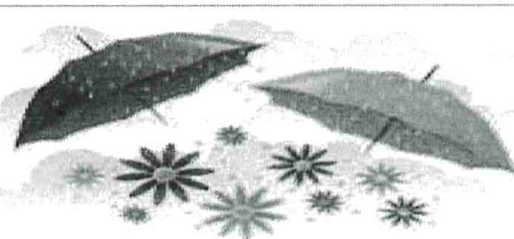

**Crossword: April 1st**

|  |  |  |
| --- | --- | --- |
|  |  |  |
| 53 |  |  |
| 56 |  |  |
| **59** |  |  |

**Down**

**1** City on the Mohawk 2Wallop

I I

|  |  |
| --- | --- |
| **Across** | I **24** "Rise, Glory, Rise" **45** Takes on some rays  composer **46** Clock std.   1. Oktoberfest drink **49** Gangster's knives 2. Toothpaste type **51** Mayberry minor   **29** Draws out **52** La Scala highlight  **32** Bumbershoot **53** Fine fabric   1. Red Square figure **54** Little bit 2. Uris hero Ben **56** _ Bator, Mongolia Canaan **57** Cognizance 3. Disregards **58** Binding 4. Pod or husk **59** Drop down? 5. Embankments **60** Octopus's defense 6. Frick collection **61** Sushi fish 7. Turning point?   42Jetty  **43** Scoundrel |
| **1** Takes advantage of  **5** Leave dumbstruck  **8** Olympics city after St. Moritz   1. Wake Island, e.g. 2. Top secret? **14** Took to court **15** Devotee 3. Church alcove 4. Equestrian gear 5. Horror film staple **20** S-shaped moldings **21** Old NOW cause 6. Domesticated 7. State firmly |

1. High priest at Shiloh
2. Catch phrases
3. Sentient
4. Extensive
5. Psychoanalysis subject
6. Inedible orange
7. Mucilage with a cape?
8. _-majeste
9. Poems of praise
10. At a distance
11. Gobbled up
12. lditarod terminus

**20** Abroad

1. Soldiers' spots, at times

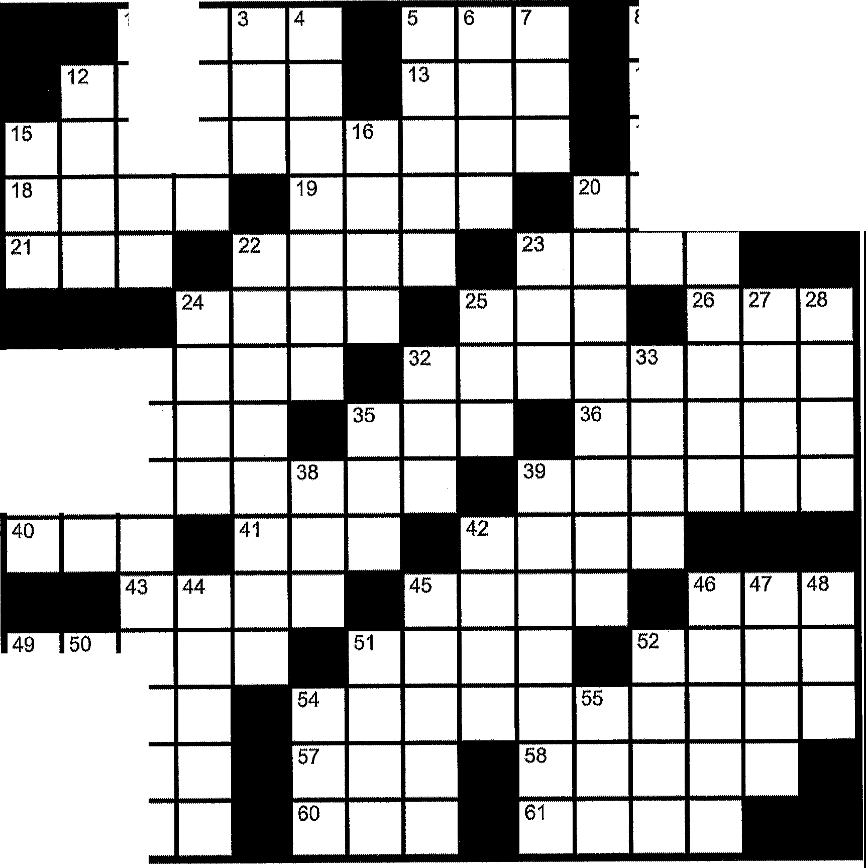

**1**

2

29 30 **31**

37

34

1. Vatican vestment **24** It has a low pH **25** "What to do?" **27** North Sea feeder **28** Glasgow gal

|  |  |  |  |
| --- | --- | --- | --- |
| 8 | 9 | 10 | 11 |
| 14 |  |  |  |
| 17 |  |  |  |
|  |  |  |  |

1. Socialite Maxwell
2. Big game
3. Close to, but not, illegal **32** North Yorkshire river **33** A deadly sin

**35** Naja haje

1. Have something to complain about
2. Oval opening; to allow light into a dome

**42** Pack it in

1. Media attraction
2. Paddle
3. Facial gestures **47** Like some vases **48** Moniker
4. Urban blight
5. Circle overhead? **51** Black cat, to some **52** See 37 Across
6. Go downhill fast?
7. Potato feature

U

*A:T*

**April 1st**

## E jS AW. E 0 1



10

D

L

S

UE

O

S

LL W I G

S

1

' ., .·- .

E

'

## A F I

C I 'O

N A D O A P S

**T GiO** RE: 0 GEES

' '

'

T A:M E AVER

**R 1 N** E A: L .



B

|  |  |  |
| --- | --- | --- |
| E G...,. ... | | |
| ,R EL |  |  |
| SNUBS  EVEES | | |

# EDU ES UM

. ..

L:E N I N IA RI i

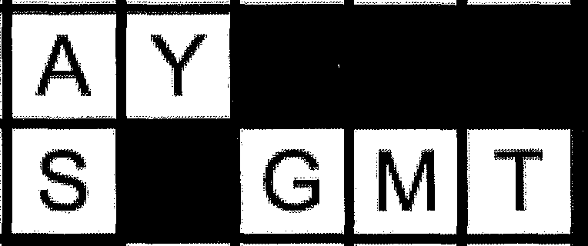

A R

T E R

I

I 'A

N G

,G

# SEED C A:I

## H

S E L

S H: --I----V-------

L

:Io

# S N:

## P I E

L A C E **U1** L **AN** M Q, L T

**S M A** T

K i E N

-

|  |  |  |  |  |
| --- | --- | --- | --- | --- |
| T E |  | YI |  | N |
| E | L | S |

I N K

i



###### Bensalem Senior Center Presents!

2025 Trips! 2026 Preview!

Don't Miss out a small deposit holds your seat

Tropicana Casino Bus Trip Smokey Robinson Tribute $87.00 Monday June 30,2025 $25.00 Deposit $20 slot play

Pa. Grand Canyon Trip $599.00 pp Double

Monday July 28 to Wednesday July 30, 2025 Deposit $100.00 (waitlist only)

Blue Crab Feast and Visionaries Thursday August 7 $199 pp deposit $50 Fun, Crab Cakes, crab cake making class and a chance to show artistic talent

S\u9Jlrotl: a11rndJ S@ll<mrndJ Ylrte, tc1r r1r®Se,!fll\S, N@ 11hlU $191 .(i))@ !Pl!Pl

1 il u d y, S:e,!}})1l;e, 11l!IQ;e,!f' 2@26; urro© l!c!ldJu!fllgi SlhJ@Jd1 Ml1;1Jlf))Ue S m@!fg)@J b@!id

E>,e,tp,©,S;Utl; $S'.© ij@

Tropicana Casino Bus Trip Blockbuster Broadway $84.00 Monday November 17,2025 $25.00 Deposit $20 slot play

A Myrtle Beach Christmas! $1065.00 pp double occupancy. Deposit $200.00 Sunday December 7th to Thursday December 11th 2025

Ocean Front Suites at The Sea Watch Resort.

4 Breakfasts, 4 Dinners 1 lunch. 3 fabulous Christmas Shows and more

2026 Preview

Seneca Niagara Resort and Casino April 26, 2026 $619.00 pp double

$100 slot play, $40 food credit 2 full American breakfasts plus boat ride on the falls and much more 3 days 2 nights $100 deposit

Selling Fas

Royal Caribbean Cruise New England and Canada!

September 17-26, 2026 $2200 pp Balcony dbl/ocean view $1654 pp dbl Inside $1434 pp dbl $300 deposit

2027 Preview

NCL Caribbean Cruise on Norwegian Pearl Feb.2-12,2027 Departs Philadelphia Balcony 2734pp double Ocean View 2374pp double Inside 2194pp double Pre Paid On board gratuities, Drink Package- Plus many additional extras

$2734 pp



Double occ.

Category BA, Double Occupancy

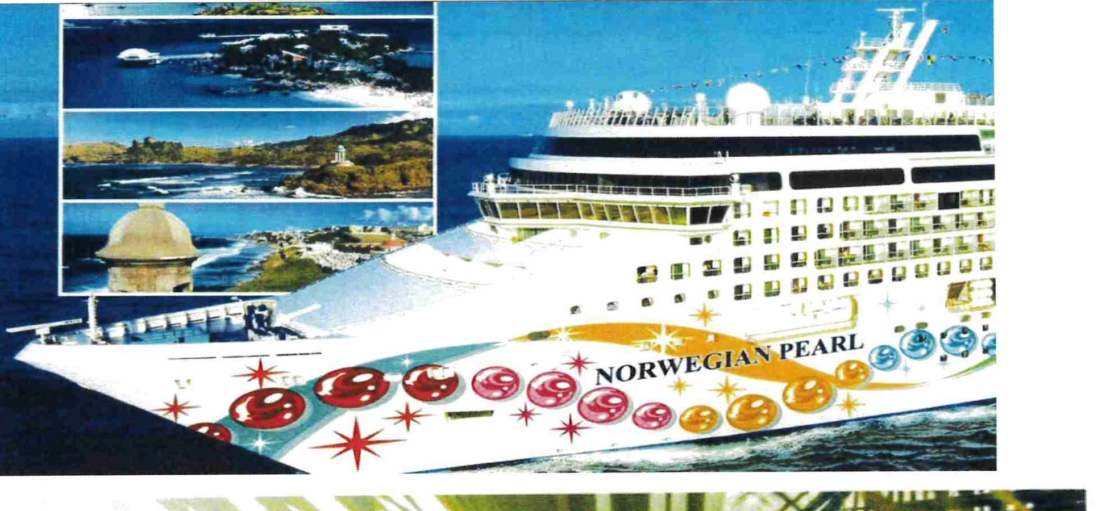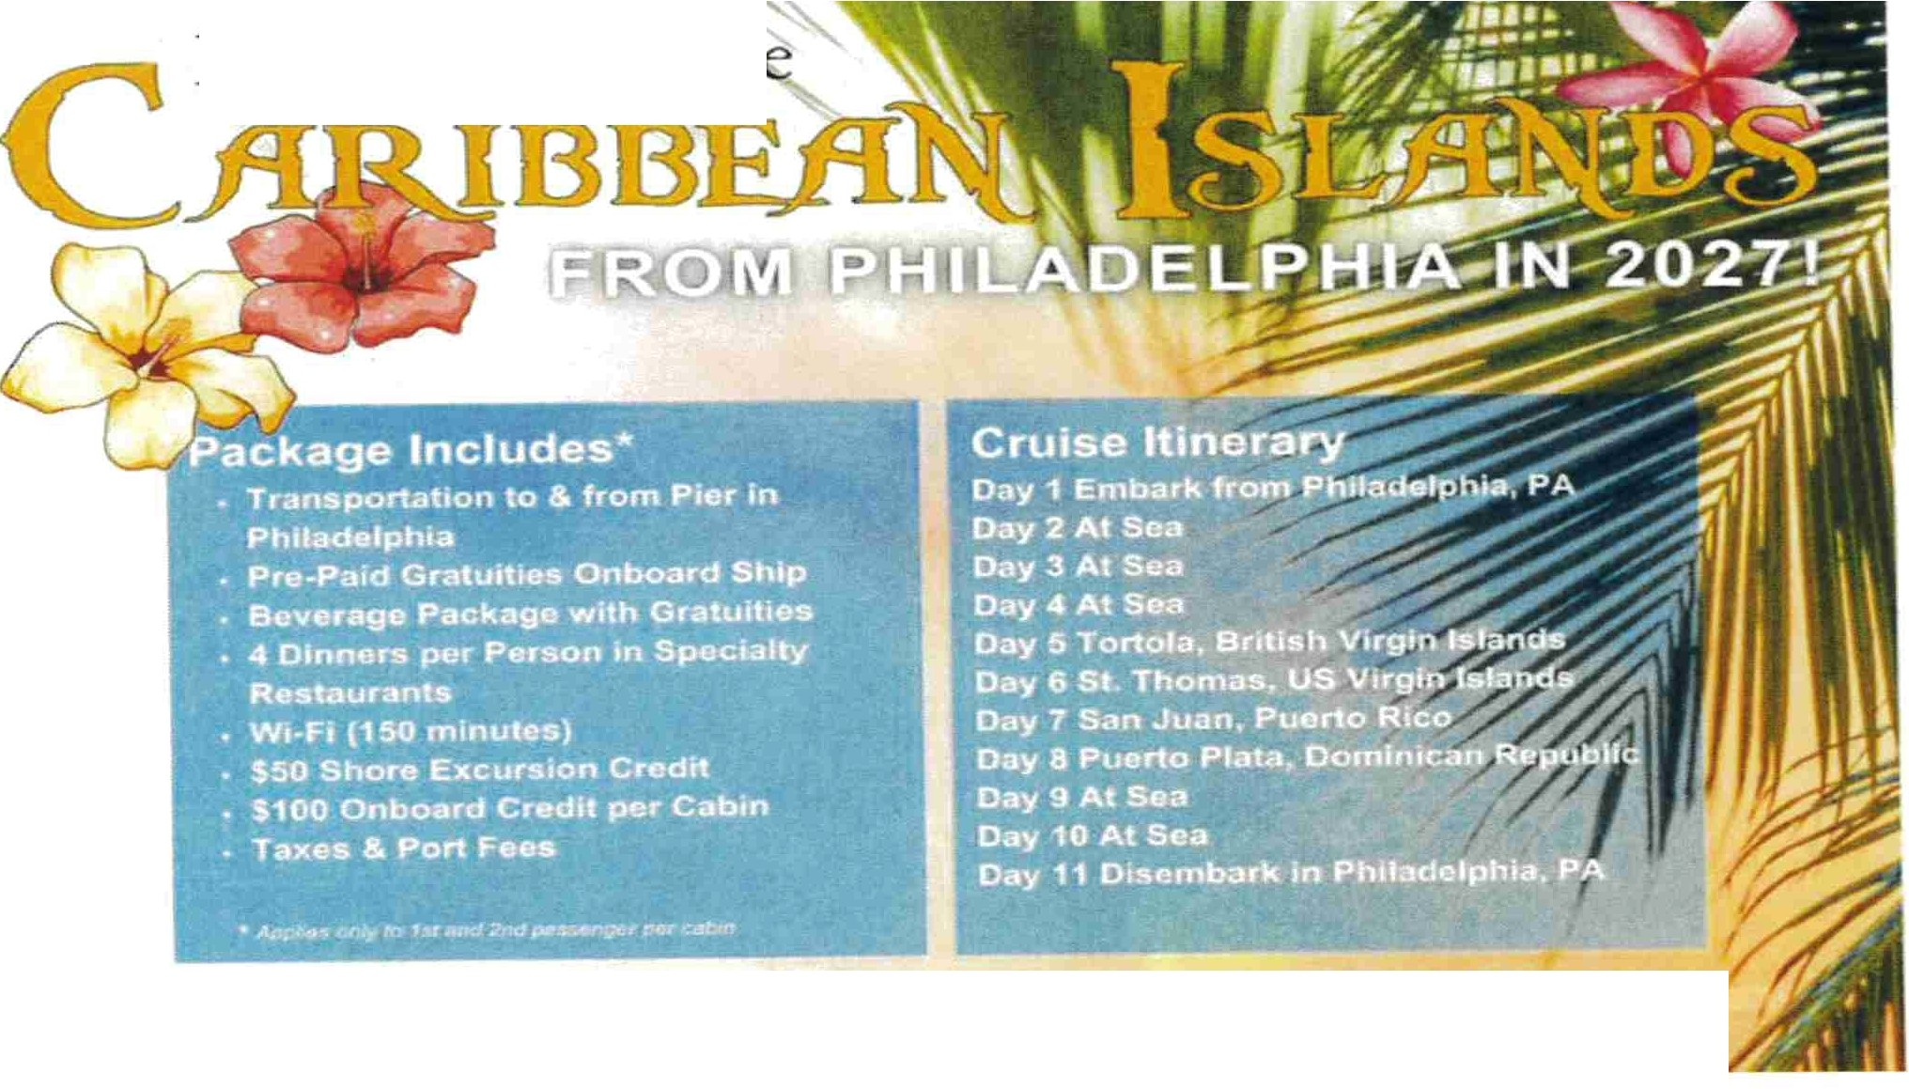

IO Nights in th

**A VALID PASSPORT IS REQUIRED FOR THIS CRUISE**

*Passport expuat,on te must o more than 6 months from the rerum date of you, er ,,so*

Bensalem Senior Center Activities

Monday-

**Pool Room** - 9am-3pm

**Ceramics-** 9am- 2:30pm

**Art Open Studio** - 9am- 3pm

**Computer Use** - 9am - 3pm

**Darts Open play** - 9am - l 2 noon

**Tai Chi Classes** -9:50am - l 0:50am

**Shuffleboard** - l 2:30om - 2:30pm

**Music Therapy** - l 2 noon - 2pm

**Pinochle** - l 2 noon - 3pm

**Dominoes** - ALL DAY

**Pool Room** - 9am - 3pm

Tuesday­

**Computer Use** -9am-3pm

**Watercolor Classes** - 9am-11am **Ceramics-9am-** 2:30pm **Shuffleboard** - l 2:30pm - 2:30pm

**Tai Chi Classes** - 9:50am -10:50am **Darts Open Play** - 9am - l 2noon **Mah Jong** - l 2noon - 3 pm

Wednesday-

**Pool Room-** 9am- 3pm **Art Acrylic Painting** - l 2noon - 2pm

**Computer Use-** 9am- 3pm **BINGO-** 12 noon - 3:30pm

**Tablet and Computer Training** - 9am-3pm **Poetry** & **Pose Group-** l 0am- 11am

**Art Drawing-** 9am-l l am

Thursday-

**Pool Room** - 9am - 3pm **Darts Open Play** - 9am- l 2 noon **Chair Yoga-** l pm **Computer Use** - 9am -3pm **Chess Club-** 9am -11am **Knit** & **Stitch** - 9:30am **Art Open Studio-** 9am-3pm **Shuffleboard** - l 0am-2pm

**Ceramics-** 9am - 2;30pm **Pinochle** - l 2noon - 3pm

Pool Room - 9am - 3pm

Computer Use- 9am - 3pm

*Friday*

Art Acrylic Paiting- l 2noon-2pm

Quilting- 4pm-8pm

Tablet and Computer Training - 9am - 3pm

Art Printmaking - 9am- l lam

Ceramics- 9am -2:30pm

Darts Open Play- 9am- l 2noon

Shuffleboard - l Oa m - 2pm

Dominoes - All day

Health & Fitness Class- l l :30am

Chess - l Oam- l 2pm Line Dancing - 9:30a m Bunco - l 2pm -2pm

Lunch

Monday - Friday @ 11am - **PLEASE ALWAYS PRE-REGISTER ON** COPILOT

MONDAYS AND THIRD THURSDAY OF THE MONTH@ 10AM WILL BE PRESENTATIONS AND

GUEST SPEAKERS!