

2025

* + - 1. Newsletter

Bensalem Senior Center l **850 Byberry Road** Bensalem PA 19020

**215-638-7720**

[WWW.Bensalemseniorcenter.com](http://WWW.Bensalemseniorcenter.com/)

### Message from The Director

Hello members, I hope everyone has been staying warm these past few weeks. Hopefully we will be welcoming nicer weather this month and no more cold bitter snow days!

Last month we lost two members who will be missed very dearly. Dolores Lynam and Thomas Amerman. When we know more about when their services are we will be sure to put that information out.

This month we are starting to get busy again so be prepared!

March 4, we have a healthy eating presentation and also Fat Tuesday Festivities starting at 12:30pm, Tea party March 7, the much­ wanted Salsa class is back March 13, March 17 is the Darts Luncheon and March 20 we have a final expense presentation- attached in the newsletter are the times and flyers of all these upcoming events!

Don't forget to purchase your Spring Fling Bingo tickets, May will be here very quickly! We are also going to have Ms. Kim come for haircuts every three weeks on a Friday starting at 1 0am- so if you are interested please see me for dates so we can get you signed up, remember haircuts are a cost of $15-$20 but she gives a percent back to the center!

**Again, please remember our new website is**

[**WWW.Bensalemseniorcenter.COM,**](http://WWW.Bensalemseniorcenter.COM/) it is still a work in progress so there is not much information but remember to update your email with Diana, check the information board when you walk into the center or even our newsletter! If you ever have questions or need information please see me and I can do my best to help!

Thank you again for all your help and support this year! Still cant believe I have been here for a year, time flies when you are having fun they say!!

Upcoming Events in March

March 4- Spring into Healthy Eating @ 12pm

March 4- Fat Tuesday Festive Celebration @ 12:30pm March 7- Nutrition Class with Jefferson @1Oam March 11- Tea Party @11am with Your Senior Savior **Coming with cakes and tea! Giving back to the**

**community! Come and enjoy some treats!**

March 13- Salsa Class @ 1pm - **May be rescheduled**

##### March 20- Final Expense presentation @ 1Oam

March 26- Sams Club discount membership @ 10 am -

**CANCELLED** - coming now 4/2

##### Lunch Every Monday- Friday @11am

**PLEASE** Preregister on Copilot

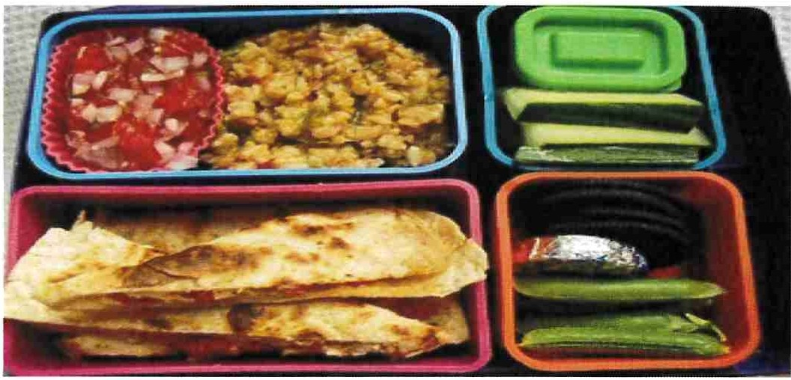

Please Be sure to Register !!

Message from the President

Greetings! It is almost Spring and I know we are ready to say goodbye to winter and hello Spring!

First of all, I know most of you know that our l st Vice President passed away a few weeks ago. She was an amazing woman and will be missed by all. I appointed Mark Helmus to fill Dolores's position. I'm sure he will do a great job.

We also lost a past president, Tom Ammerman, he was our president in 2005. Tom was an avid pinochle player and will also be missed!

It was brought to my attention that Carol Collins better known as C.J passed also, condolences go out to Tim Tracy!

No more bad news from me, it happens in 3's so hopefully we are only going to hear good news.

The Dart Season is winding down now. Playoffs will be starting very soon. In April Shuffleboard will begin. I want to thank Fran Stratton, Liz Reap and Mike Schnitzer for stepping up to the plate and will organize and lead the shuffleboard league. If you are still interested in playing shuffleboard, please sign up at the front desk.

Thanks to the township for replacing our windows. It will be great to have more energy efficient windows. Thank you, Mayor and staff!

Don't forget our Spring Fling Bingo is on Sunday, May 4th! This has always been a fun event. We still need gift cards, gift baskets or new items that we can use that day to raffle off. Thank you to those who already donated to this event. It is truly appreciated

Our Music Jam Session is doing very well every Monday. The crowd is growing and we are thrilled. They perform from l 2pm-2pm, if you haven't heard them yet, you don't know what you are missing! Check it out.

Thafs all for this month!

Love Judy

Community -. **1' '1, pa health**

**HealtliCho,ces**

**111 &wellness,.**

**Presents**

**Spring Into Healthy Eating**

Join us for this Lunch & Learn while we discuss:

Nutrition & Portion Control

Location: **Lunch Room**

Bensalem Senior Citizen's Association

Date: **Tuesday March 4th , 2025** Time: **12:00 p.m.**

PAHealthWellness.com

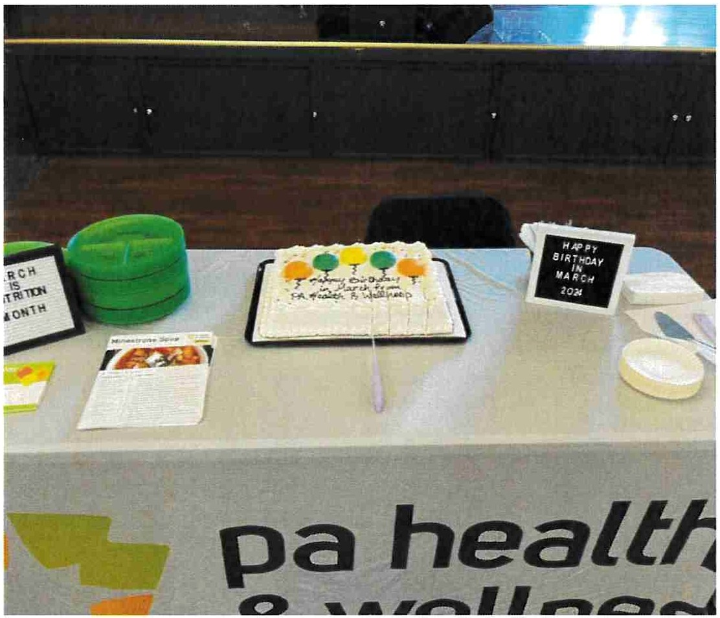

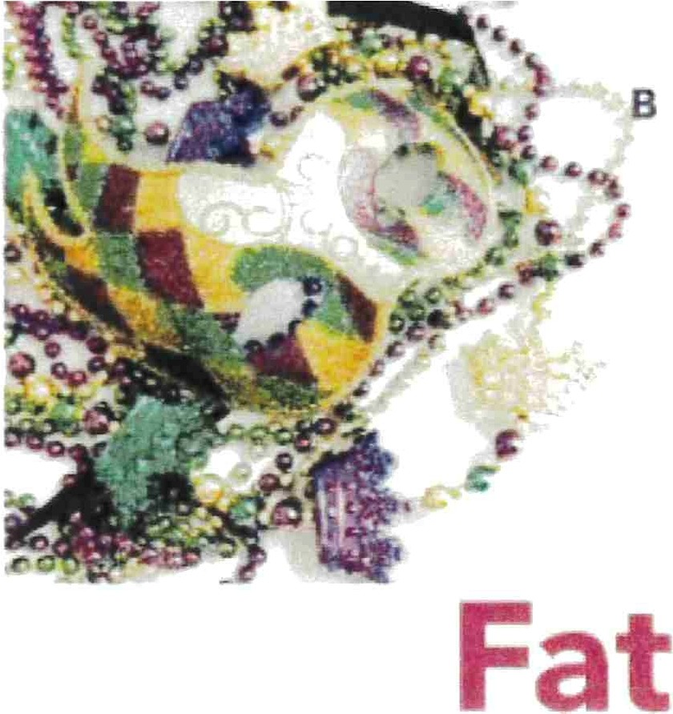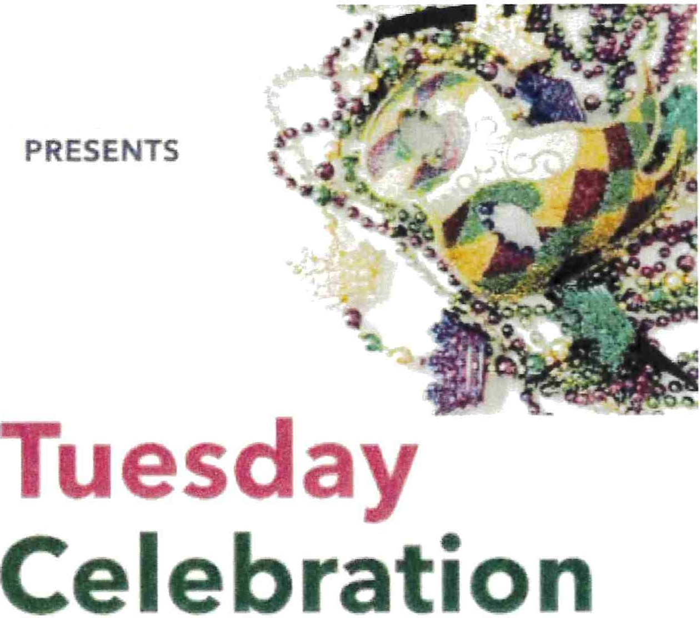E SA.LE IORS

EVE TC E



Exp,eri en ce the magic of Mardi Gras

* + - * + arch 4, 2025

1 2 0 2 10 prr

**GRAND BALLROOM**

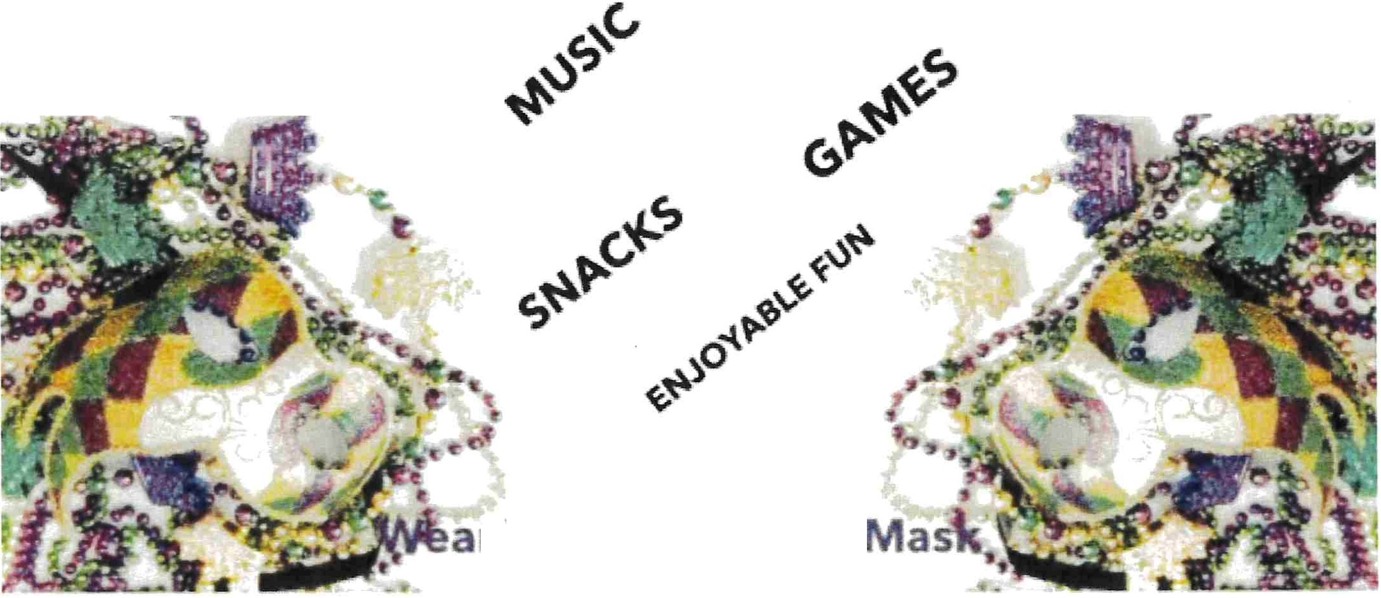

r Your Bes and a

**\-\o\t cu-ts w\1f\ K\rD.**



-

\-\air cu1s oreo cos\ ot $\ 5-$20 do\\ors

b\J1 percen1 is o\so given boc\<.1o 1ne

cen0\er\ ?\ease sign ot\ocned snee1it

in\eres\ed\\

Nex\ 001es·. Moren 71n and Moren 2s'n

lime·. \ oom- \ pm

## Come Join us for Healthy Eating Sessionsl Location: Bensalem Senior Center

Time: 10am Sessions 1: MyPlate, 3/7/25

Session 2: Nutrition Labels, 4/4/25

Session 3: Healthy Beverages, 5/2/25 Session 4: Beans w/ Navy bean 6/6/25

#### MY HeaLTHY CHeCKLIST

exercise waTer



*cC>*

easeo on 1.eoo caLones Per oay 



YOU ARE INVITED TO A

Bensalem Senior Center

# Sponsored by Your Senior Savior

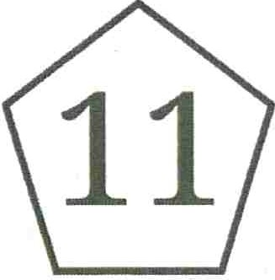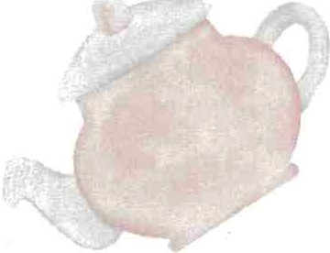 MARCH AT 11 AM

 1850 Byberry Rd,

Bensalem, PA 19020

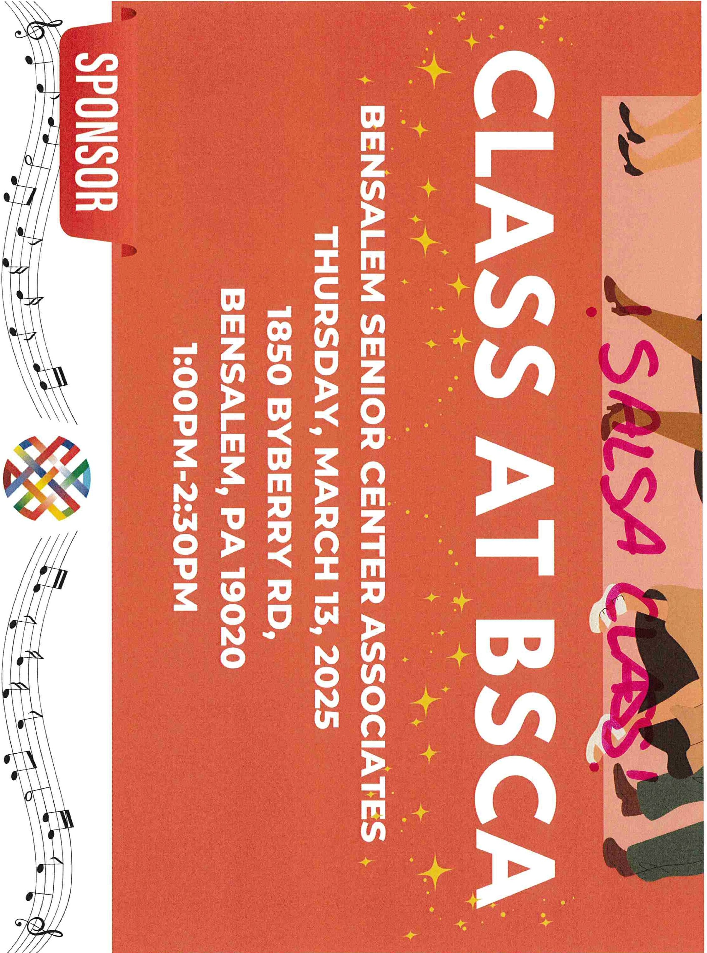

r-

J>

(i)

0

**Attention Members!**

The Bensalem Senior Center is taking applications for the county Senior Connect Program



This program provides Internet Service and a Tablet to income eligible residents of Bucks County.

**New Income Guidelines for 2025!**

1 Person Household: $20,814.50 2 Person Household: $28,129.50

Please see Roberta for more details and to enroll



$2734 pp

Double acc .

**A VALID PASSPORT IS REQUIRED FOR THIS CRUISE**

*Passport exp,rat,on dale must be mon3 than 6 months from the return* dare *of your cru,se*



Bensalem Senior Center Presents!

2025 Trips! 2026 Preview!

Don't Miss out a small deposit holds your seat

Nashville, Tennessee 5 nights 6 days $1299.00 pp double Sunday, May 18-23, 2025--Deposit $200.00

Tropicana Casino Bus Trip Smokey Robinson Tribute $87.00 Monda June 30,2025 $25.00 Deposit $20 slot play

Pa. Grand Canyon Trip $599.00 pp Double

Monday July 28 to Wednesday July 30, 2025 Deposit $100.00 (waitlist only)

S ght fl1ld S@UlfflJd Th aittre; Pl1 fe eint $ N aifrf $11 w9l l 0 pp

l'11J d y Sept®mhe;ir 1 11 2@21 ln iudtirnig Shady Mai Sm(()1rgJai$h@ird

DQp@sit $!0J W

Tropicana Casino Bus Trip Blockbuster Broadway $84.00 Monday November 17,2025 $25.00 Deposit $20 slot play

A Myrtle Beach Christmas! $1065.00 pp double occupancy. Deposit $200.00 Sunday December 7th to Thursday December 11th 2025

Ocean Front Suites at The Sea Watch Resort.

4 Breakfasts, 4 Dinners 1 lunch. 3 fabulous Christmas Shows and more

2026 Preview

Seneca Niagara Resort and Casino April 26, 2026 $619.00 pp double

$100 slot play, $40 food credit 2 full American breakfasts plus boat ride on the falls and much more 3 days 2 nights $100 deposit

Royal Caribbean Cruise New England and Canada!

September 17-26, 2026 $2200 pp Balcony dbl/ocean view $1654 pp dbl Inside $1434 pp dbl $300 deposit

2/18/25, 9:57 AM memorials.tomIinsonfh.com/dolores-lynam /5553010/obi t.php?&printable=true

IN MEMORY OF

**DOLORES**

**ANN**

###### LYNAM

**Obituary for Dolores Ann Lynam**

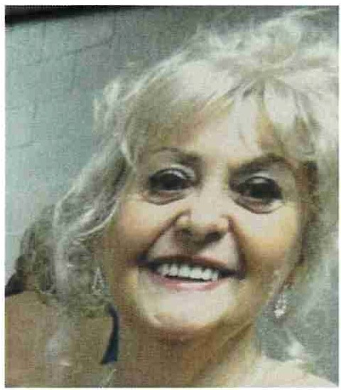Dolores A. Lynam passed away peacefully on Thursday February 13, 2025 , at the age of 85. Bmn in Philadelphia, PA, to the late Margaret Watson (Wyse) and Michael James Lynam. Dolores spent her life embodying joy, community, and a zest for life in her home of Langhorne, PA.

Dolores was a proud graduate of St. Hube1i's Girls Catholic School and dedicated 34 years of her life as a meat wrapper

at Grand Union Supe1market, proudly serving her local community. Known for her waim smile and infectious laughter, she was a beacon of joy in every room she entered.

Beyond her vocation, Dolores had a passion for dancing, particularly tap and Irish dance, often lighting up the stage at family gatherings and local festivals. Her competitive spirit shone through in her time spent in dart and shuffleboard leagues, where she made countless friends and often brought home trophies. As a cherished member of the Ladies Ancient Order of the Hibernians, she celebrated her heritage and shared her love for the Irish community deeply. Additionally, Dolores proudly served as the vice president of the Bensalem Senior Center, where she fostered connections and organized events that brought joy to many.

Dolores will be deeply missed by her children, John Fowler and Dawn Walker. She is also survived by her grandchildren : William, Nicki (David), Brian (Kelly), Jennifer (Daniel), Katie, Michelle, Vic, Chrissy, John and Amanda and her great grandchildren, Scarlett and Sadie. Dolores was preceded in death by her children, Valerie Fowler and Dennis Fowler and her grandson, Aaron Fowler.

A celebration of life will be held for Dolores at a later date. Memorial contributions in her memory can be made to the Ancient Order of Hibernians, Michael Dougherty Division #1, 614 Corson St, Bristol, PA 19007. [www.tomlinsonfh.com](http://www.tomlinsonfh.com/)

https://memorials .tomIinsonfh.com/dolores-lynam /5553010/obit.php?&printable=true 1/2

2/20/25, 10:44 AM memorials.tomlinsonfh.com/thomas-amerman/5553900/obit.php?&printable=true

IN MEMORY OF

###### THOMAS AMERMAN

**Obituary for Thomas Amerman**

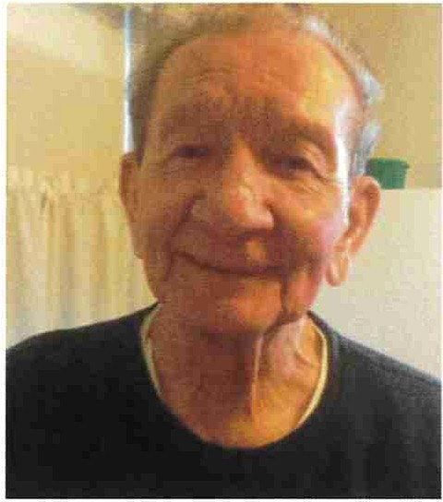It is with heavy hearts that we announce the passing of Thomas Amerman , beloved father, grandfather, great grandfather, brother, uncle and friend, who left us peacefully on February 17, 2025, at the age of 87. Born on June 27, 1937, in Philadelphia , PA, to the late George and Anna Amerman, Thomas lived a life filled with love, dedication, and service to his family and community.

A proud Navy veteran, Thomas served his country from June 24, 1955, until July 7, 1958. After returning home, he devoted himself to a fulfilling career as a groundskeeper for the Bensalem School District, where he shared his passion for nature and instilled a love for the outdoors in many students and staff members alike.

Thomas is survived by his loving family: his children William Amerman (Kim), Thomas Amerman (Kathy), Lori Amerman-Moxley (Danny), Lisa Amerman, his grandchildren , William Jr., Nicole (Jon), Tommy, Kristin (Mike), Ryan, Kevin, Maddy, Lura, Sam, and Matthew, his great grandchildren, Tommy, Haley, Chase, Carter, and Braelynn , and his sister Florence Marback (the late Joe). He was preceded in death by his beloved wife, Lura Lee, and his siblings, George, Frank, Marie, Annie, Harry, Charlie, Herb, Alice, Elmer, and Margaret. His family will forever hold dear the memories of his warm spirit, infectious laughter, and the many hours spent playing cards at the Bensalem Senior Center.

Thomas will be honored in a funeral service that will be held on February 23, 2025, at 11:00 am at the Tomlinson Funeral Home, with a public viewing taking place earlier that day from I 0:00 am to 11:00 am. Interment will be private. In lieu of flowers, donations can be made in Thomas' name to the Bensalem Senior Citizens Association, 1850 Byberry Road, Bensalem, Pa 19020.

In this time of grief, his family invites all who knew and loved Thomas to join in celebrating his remarkable life and the indelible impact he has made. He will be deeply missed but forever remembered in the hearts of those he touched.

https://memorials.tomlinsonfh.com/thomas-amerman/5553900/obit.php?&printable=true 1/2